McKendree University Love You 5(k) EVER- Run & Walk
- WHEN: Saturday, April 13th, 2024; 8am CST
- FOR: Love You More Foundation
- ORGANIZED BY: SPM-376 (14 Students + Professor)
- Ca. 120 participants
- 18-20 Volunteers will be placed along the route to protect the runners; One at each turn & 2 at any intersection
Race Route:
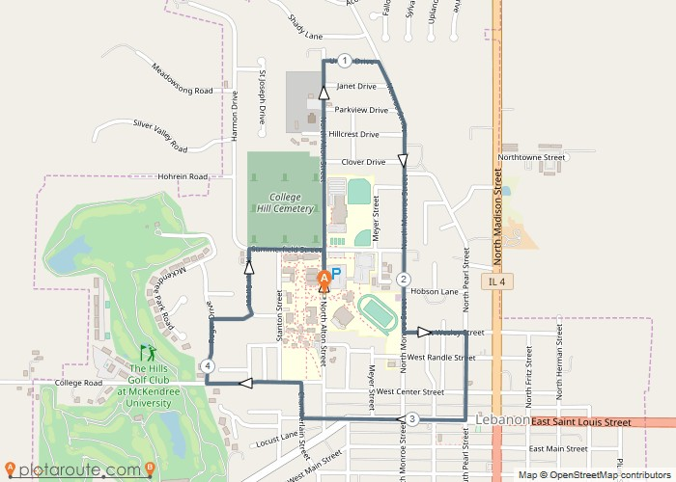

- Participants will run clockwise Starting in front of the Hett on the McKendree Campus
- Runners will head North on N Alton St. to Ursula Drive and turn right onto Monroe St
- Heading South on Monroe St past Leemon Field and turn left onto W Wesley St
- Runners will then turn right onto Pearl St heading towards W St Louis St and take another right
- Travel on west on W St louis St until you reach N Chamberlin St where they will turn right
- Runners will travel on N Chamberlin St then take a left onto college Rd heading all the way to Roger Dr where they will then head right, then take another right once reaching Meril St
- Once on Meril St runners will then turn left onto Hunter St until they reach Summerfield St where they will turn right
- Once on Summerfield St they will turn right onto N Alton St for the final stretch of the race where it will conclude back at The Hett on McKendree’s campus

